**SINUSOIDAL FUNCTIONS (Chapter 8)**

**LESSON 1 - Angles: Degrees and Radians**

| **VOCABULARY**  **radian**: the measure of the central angle of a circle subtended by an arc that is the same length as the radius of the circle. |
| --- |

Radian measure is an alternative way to express the size of an angle. One radian measure is approximately 60°.

Using radians allows you to express the measure of an angle as a real number without units.

So, if we express the measurement of an angle in degrees, we must write the degree symbol (º).

Ex: 75˚ represents 75 degrees

110 represents 110 radians

The central angle formed by one complete revolution in a circle is 360°, or 2 in radian measure.

Since, 360°= 2, then 180°= .

**Converting from degrees to radians**

To convert an angle from degrees to radians, we multiply the angle by .

*Example*: Convert 135º to radians

*Solution*:

**Converting from radians to degrees**

To convert an angle from radians to degrees, we multiply the angle by .

*Example*: Convert 1.24 radians to degrees

*Solution*:

**EXAMPLE 1**

**Determine** the value of each angle in radian measure.

1. 90° b) 120°

c) 225° d) 330°

**EXAMPLE 2**

**Determine** the value of each angle in degrees.

a) b)

c) d)

**EXAMPLE 3**

**Determine** which angle is larger: or 8.

**LESSON 2 - Sine and Cosine Graphs**

**Exploration:**

1. Complete the table below.

| **Angle** |  |  |
| --- | --- | --- |
| 0° |  |  |
| 30° |  |  |
| 60° |  |  |
| 90° |  |  |
| 120° |  |  |
| 150° |  |  |
| 180° |  |  |
| 210° |  |  |
| 240° |  |  |
| 270° |  |  |
| 300° |  |  |
| 330° |  |  |
| 360° |  |  |

2. Sketch the graph on the interval .

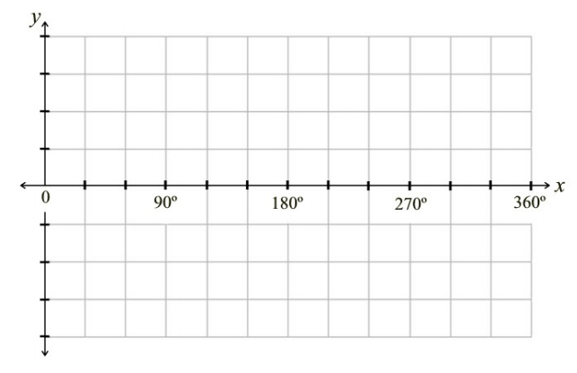

3. Sketch the graph on the interval .



| **Vocabulary**:  **periodic function:** A function whose graph repeats in regular intervals or cycles.  **midline:** The horizontal line halfway between the maximum and minimum of a periodic function.    **amplitude:** The distance from the midline to either the maximum or minimum value of a periodic function; the amplitude is always expressed as a positive number.    **period:** The length of the interval of the domain to complete one cycle. |
| --- |

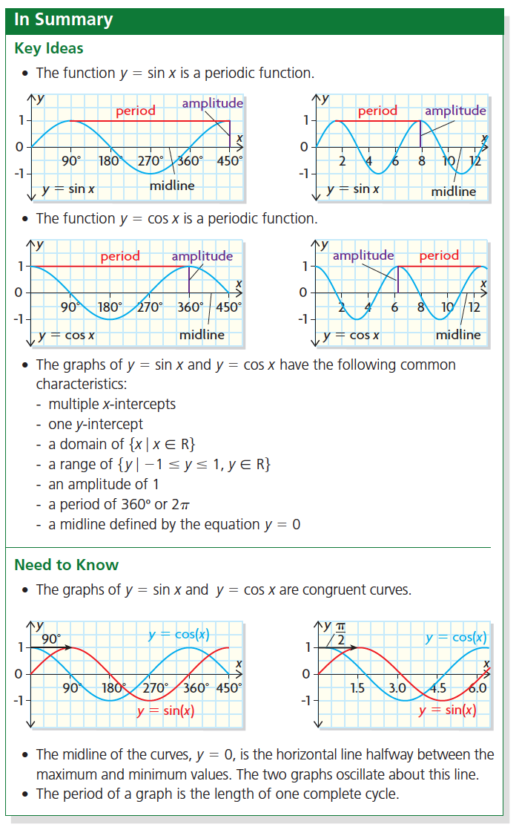

**Practice**

1. Sketch the graph on the interval .

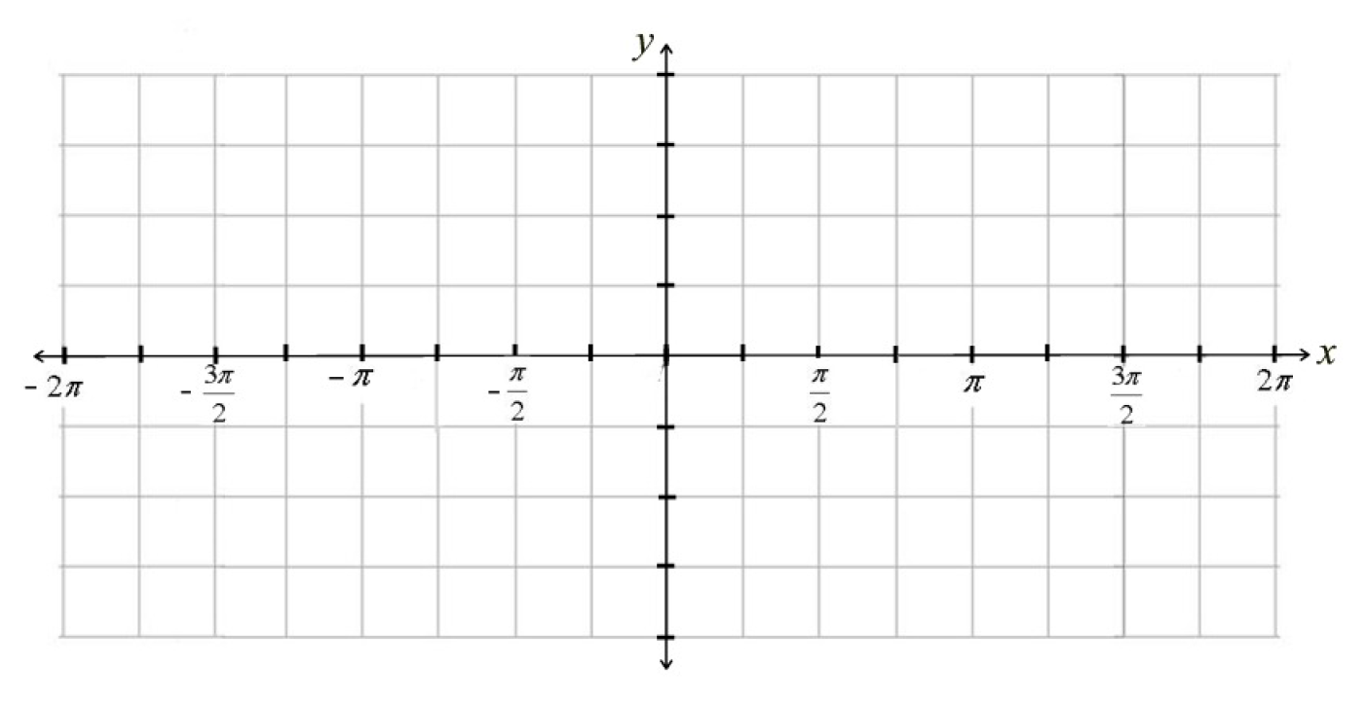

Domain: ________________________ -intercepts: ________________________

Range: ________________________ -intercept: ________________________

2. Sketch the graph on the interval .



Domain: ________________________ -intercepts: ________________________

Range: ________________________ -intercept: ________________________

**LESSON 3 - Graphs of Sinusoidal Functions & Sinusoidal Equations**

**Exploration:**

Directions: Examine the graphs of the first two equations in the table below. The characteristics of each graph are recorded to the right of each sketch. Use your calculator to complete the table for the last two equations. There are three sections each with a short summary at the end.

**SECTION 1**

| **Equation** | **Graph** | **Equation of**  **the Midline** | **Amplitude** | **Period** |
| --- | --- | --- | --- | --- |
|  |  |  | 1 unit |  |
|  |  |  | 1 unit |  |
|  |  |  |  |  |
|  |  |  |  |  |

**Summary: When a sinusoidal equation is written in the form , the letter *d* represents ___________________________ . The entire graph will move up or down *d* units.**

**SECTION 2**

| **Equation** | **Graph** | **Equation of**  **the Midline** | **Amplitude** | **Period** |
| --- | --- | --- | --- | --- |
|  |  |  | 1 unit |  |
|  |  |  | 2 units |  |
|  |  |  |  |  |
|  |  |  |  |  |

**Summary: When a sinusoidal equation is written in the form , the letter *a* represents ________________________ . The entire curve will fall *a* units above and below _____________________.**

**SECTION 3**

| **Equation** | **Graph** | **Equation of**  **the Midline** | **Amplitude** | **Period** |
| --- | --- | --- | --- | --- |
|  |  |  | 1 unit |  |
|  |  |  | 1 unit |  |
|  |  |  |  |  |
|  |  |  |  |  |

**Summary: When a sinusoidal equation is written in the form , the letter *b* changes the length of the ________________________ . The entire curve will stretch horizontally. The period is equal to _____________________.**

**A sinusoidal function can be expressed as either a cosine function or a sine function.**

The value of *a* is the **amplitude**.

**a =**

The value of *b* is the number of cycles in 360° or 2. The **period** is

**p =** *(in radian measure)*

The value of *c* indicates a horizontal translation that has been applied to the graph of or .

| In the graph of a sine function, *c* is the distance from the vertical axis to the first midline point where the graph is increasing. | In the graph of a cosine function, *c* is the distance from the vertical axis to the first maximum point. |
| --- | --- |
|  |  |

The **equation of the midline** is . Note: Midline = Medan Line

**d** **=**

The **range** of a sinusioidal graph is:

OR

**EXAMPLE 1**

| Consider the function where . |
| --- |

a) State the amplitude, the equation of b) Sketch the graph.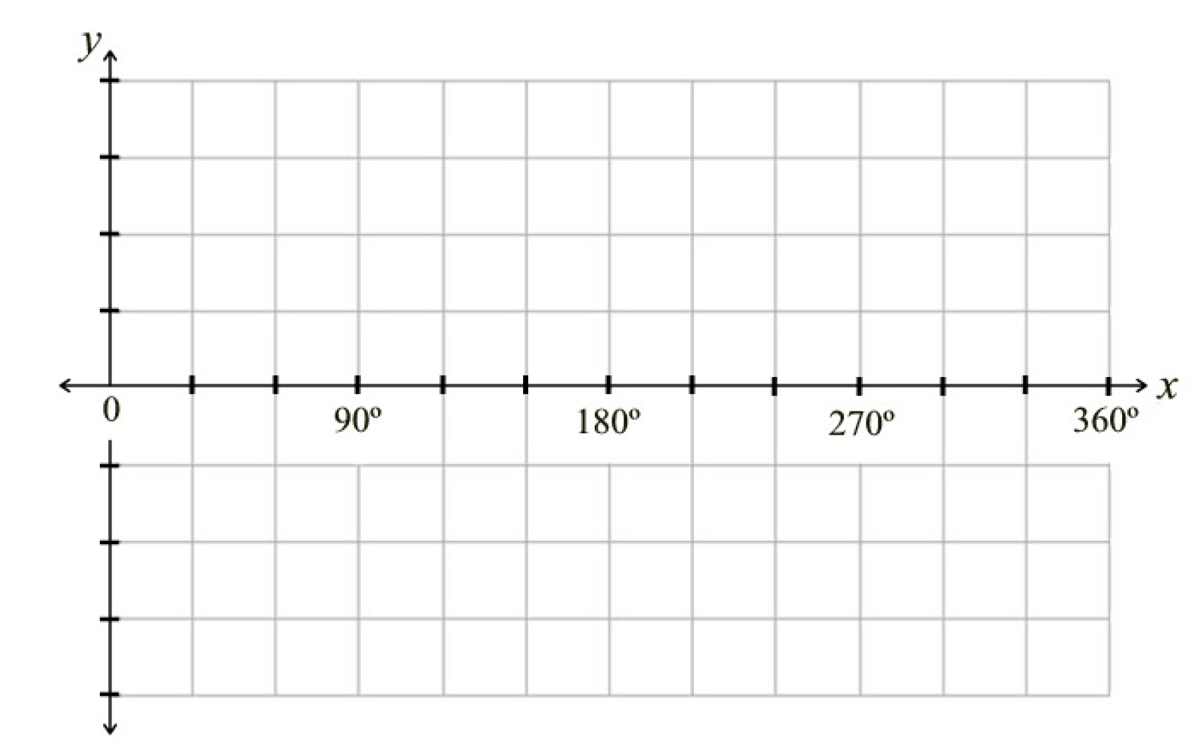

the midline, range and period of the function.

​

**EXAMPLE 2**

| Consider the function where . |
| --- |

a) State the amplitude, the equation of b) Sketch the graph.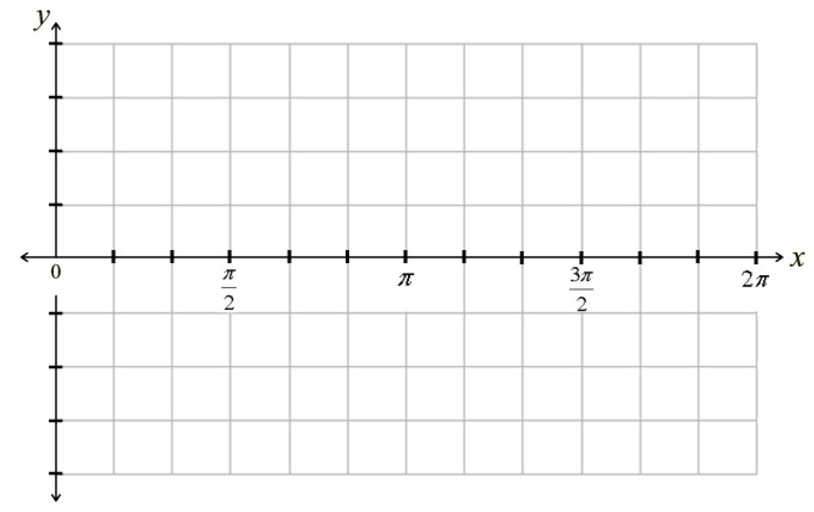

the midline, range and period of the function.

**EXAMPLE 3**

a) Write an equation of a sine function with the given characteristics:

an amplitude of 6, the equation of the midline is , a period of .

b) Write an equation of a cosine function with the given characteristics:

a range of 6, the equation of the midline is , a period of .

**EXAMPLE 4**

**Determine** the amplitude, the equation of the midline, range and period of the following function.

a) b)

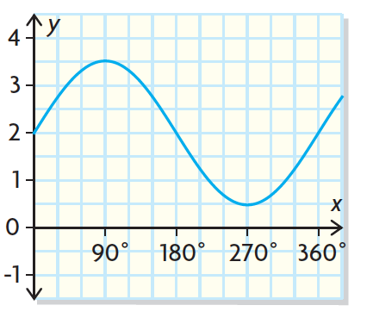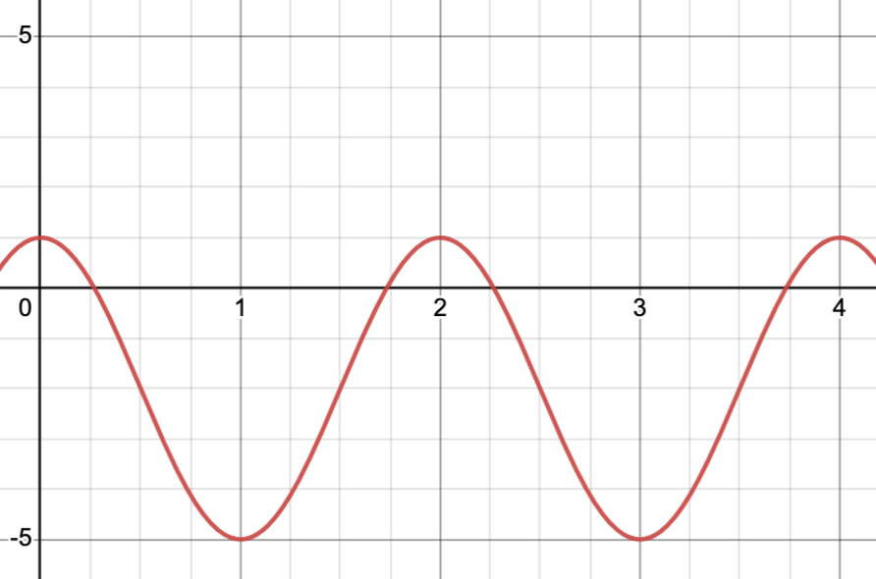

**Practice**

1. Complete the following table.

| **Equation** | **Amplitude** | **Equation of**  **the Midline** | **Range** | ***b*-value** | **Period** |
| --- | --- | --- | --- | --- | --- |
|  |  |  |  |  |  |
|  |  |  |  |  |  |
|  |  |  |  |  |  |
|  |  |  |  |  |  |
|  |  |  |  |  |  |
|  |  |  |  |  |  |
|  |  |  |  |  |  |
|  |  |  |  |  |  |

2. Sketch a possible graph of a sinusoidal function with the following characteristics.

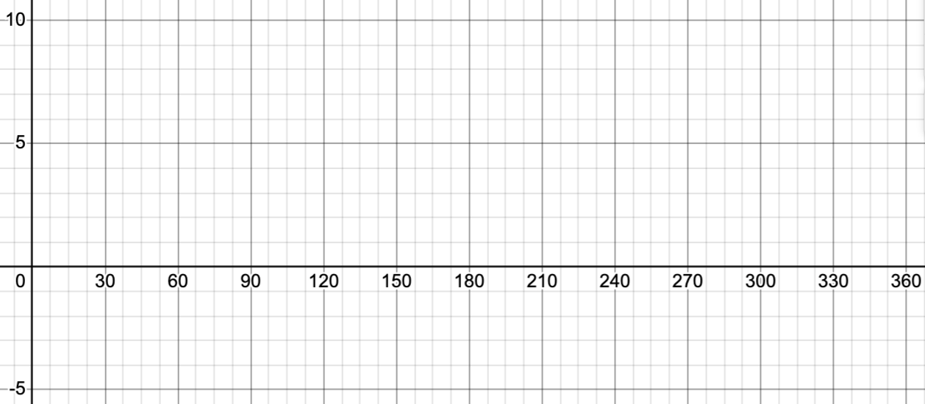

a) Domain:

Range:

Period: 90°

*y*-intercept: 4

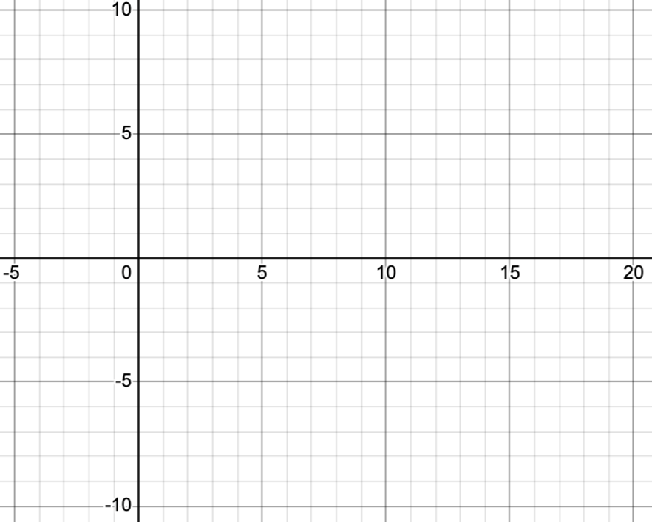

b) Domain:

Maximum value: 3

Minimum value:-3

Period: 8

*y*-intercept: 3

3. a) Write an equation of a sine function with the given characteristics:

an amplitude of 5, the equation of the midline is , a period of .

b) Write an equation of a cosine function with the given characteristics:

a range of 10, the equation of the midline is , a period of .

4, **Determine** the amplitude, the equation of the midline, range and period of the following function.

a) b) 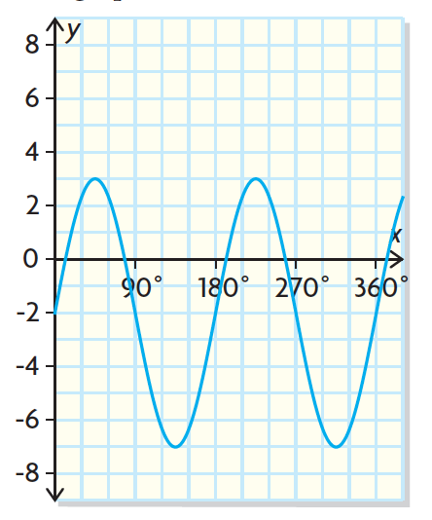

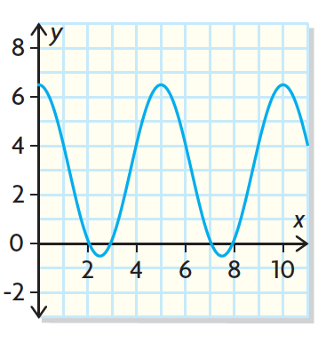

*Use the following information to answer the next question.*

| The partial graph of the function  is shown.  The graph has a maximum at and a minimum at . |
| --- |

5. Based on the information above, the value of d, correct to the nearest whole number, is ______.

**LESSON 4 - Applications of Sinusoidal Functions**

| **Vocabulary:**  **sinusoidal function**: Any periodic function whose graph has the same shape as that of or . |
| --- |

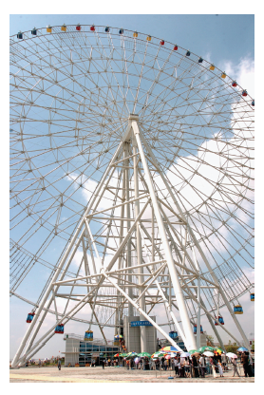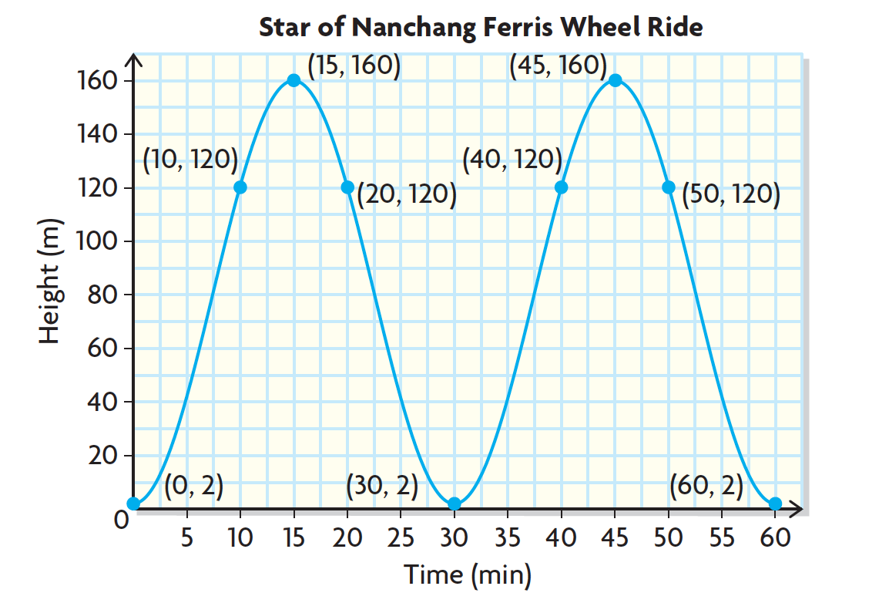

**Analyzing a problem**

Students from Simone’s graduating class went on an exchange trip to China and rode the Star of Nanchang, one of the tallest Ferris wheels in the world. Simone graphed the sinusoidal function that represented the ride.

1. State the y-intercept. What does this value represent in context of the situation?

2. State the maximum value of the graph. What does this value represent in context of the situation?

3. State the range of the graph. What does this value represent in context of the situation?

4. State the amplitude of the graph. What does this value represent in context of the situation?

5. State the equation of the midline. What does this value represent in context of the situation?

6. State the period of the graph. What does this value represent in context of the situation?

7. How long does it take to get to the top of the Ferris wheel from the bottom?

8. How long is the rider above 120 meters during the first rotation of the Ferris wheel?

**EXAMPLE 1**

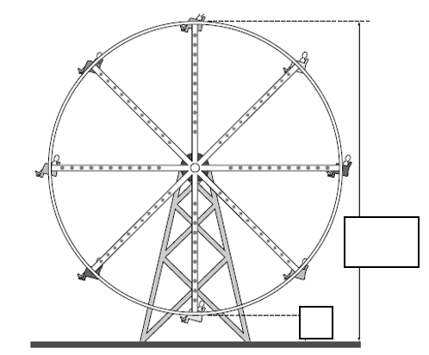

The equation represents the turning of a Ferris wheel. The *t* represents the time (in minutes) and *h* is the height (in metres).

a) What is the radius of the Ferris wheel?

b) How high is the bottom of the Ferris wheel from the ground?

c) What is the maximum height of the Ferris wheel?

d) How long does it take the Ferris wheel to go around one time?

e) How high is a car 22 minutes into the ride?

f) When is one car on the Ferris wheel at 100m for the first time?

g) How long, to the nearest tenth, is the Ferris wheel above 100 m during the first revolution?

**Practice**

*Use the following information to answer the next question.*

| A ball floating on the ocean moves up and down with respect to the ocean floor as the waves flow beneath it. The movement of the ball can be represented by the following function  where *y* is the distance, in inches, between the ball and the ocean floor and *x* is the time, in seconds. |
| --- |

1. During the first 5 seconds, the number of seconds that the height of the ball will be over 70 inches, to the nearest tenth of a second, is _________*s*.

*Use the following information to answer the next question.*

| The graph at right is a tidal graph for New Glasgow, N.S. The *x*-axis is the time in hours and the *y*-axis is the height of the water in meters. |
| --- |

2. Use the graph to **determine** following (show any work necessary).

a) Equation of the Midline

Amplitude

Period

b) **Explain** what the amplitude represents in this situation.

c) **Explain** what the *y-*intercept represents in this situation.

d) Estimate the times of the day the depth of the water is exactly 3 metres.

*Use the following information to answer the next question.*

| Two Ferris wheels are shown below. The height above the ground of a rider on the smaller Ferris wheel can be modelled by the sinusoidal function  where *h* is the height in meters and *t* is the time in minutes. The period is the same for both Ferris wheels. |
| --- |

3. **Compare** the parameters *a*, *b*, and *d*.

*Use the following information to answer the next question.*

| The function , where *T*  is the temperature in °C and *d* the day of the year, can be used to predict the daily maximum temperature in Grande Prairie, Alberta. |
| --- |

4. a) The period for the function, to the nearest day, is ___________.

b) The maximum daily temperature for August 1st, the 214th day of the year, in degrees Celsius will be:

**A**. –3.4 °C **B**. 4.6 °C **C**. 6.2 °C **D**. 11.5 °C

c) The number of days over the course of a year, that the temperature will be over 15 degrees, to the nearest day, is _________.

*Use the following information to answer the next question.*

| A circular carousel is shown below. The starting position of a horse, halfway between the top and the bottom of the carousel, is marked by a black dot.    The height of the horse can be modelled by the function  where *t* is time, in seconds, and *h* is the height of the centre of the horse, in feet. |
| --- |

5. a) The maximum height of the horse is _________ feet.

b) The time it takes for the horse to return to its original position, to the nearest second is _________.

c) The average height of the horse is ___________ feet.

*Use the following information to answer the next question.*

| The average temperature of a particular town in Alberta can be represented by the function  where *T* is the average temperature in degrees Celsius and *t* is the time in months after January 1. |
| --- |

6. The minimum number of months, to the nearest tenth of a month, it takes for the average temperature of the town to rise from 5 ºC to 15 ºC is

**A.** 1.3 months

**B.** 2.6 months

**C.** 3.0 months

**D.** 4.3 months

**LESSON 5 - Sinusoidal Regressions**

**EXAMPLE 1**

Below is a table that shows the average temperature of a town over the course of a year. Plot this data on the and answer the following questions.

| **Month** | 1. Jan | 2. Feb | 3. Mar | 4. Apr | 5. May | 6. Jun | 7.  Jul | 8. Aug | 9. Sept | 10. Oct | 11. Nov | 12. Dec |
| --- | --- | --- | --- | --- | --- | --- | --- | --- | --- | --- | --- | --- |
| **Average Temp** | -3°C | -1°C | 4°C | 10°C | 16°C | 21°C | 23°C | 22°C | 15°C | 10°C | 4°C | -3°C |

1. State the regression equation using your calculator. Round all values to the nearest tenth.

2. **Determine** the maximum and minimum values of the graph.

3. State the value of the median line. What does this line represent in the context of the question?

4. State the value of the amplitude. What does this value represent in the context of the question?

5. What does the *y-*intercept represent in the context of the question?

6. What is the period of the graph?

7. During one year, how long is the average temperature above 15°C, to the nearest tenth.

8. If the average monthly temperature in the town increases by 2°C, how would this affect the graph.

**Practice**

1. This table shows the sunrise times on the first day of each month in 2005 for a major Canadian city.

| **First Day of** | **Day of Year** | **Time of Sunrise** |
| --- | --- | --- |
| January | 1 | 8.67 |
| February | 32 | 8.22 |
| March | 60 | 7.33 |
| April | 91 | 6.18 |
| May | 121 | 5.15 |
| June | 152 | 4.45 |
| July | 182 | 4.43 |
| August | 213 | 5.03 |
| September | 244 | 5.83 |
| October | 274 | 6.62 |
| November | 305 | 7.48 |
| December | 335 | 8.30 |

a) **State** the sinusoidal regression rounding all values to two decimal places.

**Hint:** you must write down *y =* for full marks on your exams.

b) **Determine** the minimum and maximum sunrise times, rounded to the nearest tenth.

c) **Determine** the median sunrise time, to the nearest tenth, using your values from **b)** and **explain** the meaning of this value in the context of the question.

d) **State** the amplitude, to the nearest tenth, using your values from **b)** and **explain** the meaning of this value in the context of the question.

e) **Determine** the period using the maximum and/or minimum points of the graph. Did you get the answer you were expecting? **Explain**.

f) At what time will the sun rise on June 12th (Day 163)?

g) On which day(s) will the sun rise at about 8:30 in the morning?

2. The following table shows the average monthly temperatures in Winnipeg, Manitoba, over a period of one year.

| **Month** | **Average Temperature (°C)** |
| --- | --- |
| 1. January | –18 |
| 1. February | –18 |
| 1. March | –11 |
| 1. April | 0 |
| 1. May | 11 |
| 1. June | 18 |
| 1. July | 20 |
| 1. August | 19 |
| 1. September | 14 |
| 1. October | 7 |
| 1. November | –8 |
| 1. December | –17 |

a) **State** the sinusoidal regression, round your values to the nearest tenth.

b) **Determine** the length of the period to the nearest tenth. **Explain** how the period relates to context.

c) **Explain** what the value of *d* represents in this situation.

d) The growing season is the part of the year in which the average temperature remains above 5°C. What is the growing season in Winnipeg? **Justify** your answer using data from the graph or equation above.

*Use the following information to answer the next question.*

| A Ferris wheel has a radius of 8 m. Its center is 10 m above the ground. A rider gets on the Ferris wheel at its lowest point and completes one full revolution in 48 seconds. The height of the rider at different times during the ride is shown below.   | **Time**  **(seconds)** | 0 | 12 | 24 | 36 | 48 | 72 | | --- | --- | --- | --- | --- | --- | --- | | **Height**  **(m)** | 2 | 10 | 18 |  | 2 | 18 | |
| --- | --- | --- | --- | --- | --- | --- | --- | --- | --- | --- | --- | --- | --- | --- |

3. The height of the Ferris wheel, to the nearest metre, 36 seconds after the ride begins is_______ m.